Chapter 16

Database Administration and Security

Discussion Focus

The following discussion sequence is designed to fit the chapter objectives:
- Illustrate the value of data as a corporate asset to be managed.
- Explain the data-information-decision cycle and demonstrate how this cycle may be supported through the use of a DBMS.
- Emphasize the role of databases within an organization and relate this role to the data-information-decision cycle; then show how this role is essential at all managerial levels.
- Discuss the evolution of the data administration (DA) function, starting with the DP department and ending with the MIS department. During this discussion, emphasize the change in managerial emphasis from an operational orientation to a more tactical and strategic orientation. Illustrate how a DBMS can foster a company's success; examples from companies involved in banking, air services, and financial services are particularly illustrative.
- Show the different ways of positioning the DBA function within an organization; emphasize how such positioning is a function of the company's internal organization.
- Contrast the DBA and DA functions.
- Discuss the DBA's technical and managerial roles.
- Explain the importance of data security and database security.
- Show how data dictionaries and CASE tools fit into data administration.

Answers to Review Questions

Note: To ensure in-depth chapter coverage, most of the following questions cover the same material that we covered in detail in the text. Therefore, in most cases, we merely cite the specific section, rather than duplicate the text presentation.

- Explain the difference between data and information. Give some examples of raw data and information.

Given the importance of the distinction between data and information, we addressed the topic in several chapters. This question was first addressed in Chapter 1, “Database Concepts,” Section 1-1, “Data vs. Information.” Emphasize that one of the key purposes of having an information system is to facilitate the transformation of data into information. In turn, information becomes the basis for decision making. (See Figure 16.1, “The data-information-decision making cycle”)

We revisit the data/information transformation in Chapter 13, “Business Intelligence and Data Warehouses,” Section 13-1, “The Need for Data Analysis.” Section 13-2, “Business Intelligence,” addresses the Decision Support System (DSS),” addresses the use of a comprehensive, cohesive, and integrated framework , which is designed to assist managerial decision making within an organization and which, therefore, includes an extensive data-to-information transformation component. Figures 13.1 (Business Intelligence Framework) and 13.2 (Business Intelligence Components) illustrate the BI's main components, so use these figures as the focus for discussion. Finally, review the operational data transformation to decision support data, using Figure 13.3, “Transforming Operational Data into Decision Support Data,” as the basis for discussion.

Data are raw facts of interest to an end user. Examples of data include a person's date of birth, an employee name, the number of pencils in stock, etc. Data represent a static aspect of a real world object, event, or thing.

Information is processed data. That is, information is the product of applying some analytical process to data. Typically, we represent the information generation process as shown in Figure Q16.1.

Figure Q16.1 Transformation of Data Into Information
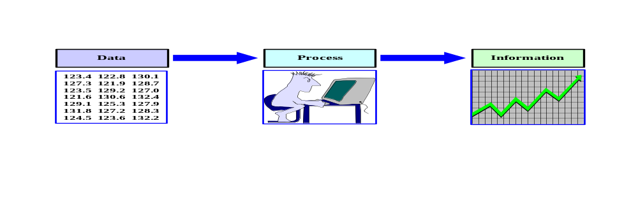

For example, invoice data may include the invoice number, customer, items purchased, invoice total, etc. The end user can generate information by tabulating such data and computing totals by customer, cash purchase summaries, credit purchase summaries, a list of most-frequently purchased items, etc.

Since the data-information transformation is crucial, it is important to keep emphasizing that data stored in the database constitute the raw material for the creation of information. For example, data in a CUSTOMER table might be transformed to provide customer information about age distribution and gender as shown in Figure Q16.2:

Figure Q16.2 Customer Information Summary
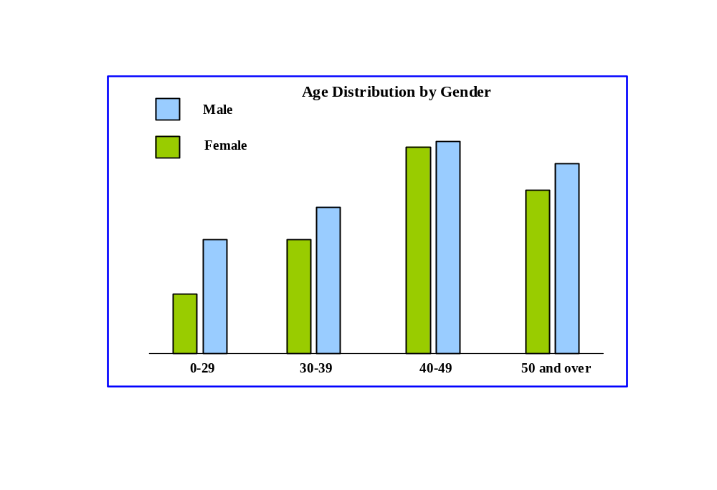

Similarly, data in a CAR table might be transformed to provide information that relates displacement to horsepower as shown in Figure Q16.3:

Figure Q16.3 Engine Horsepower vs. Displacement
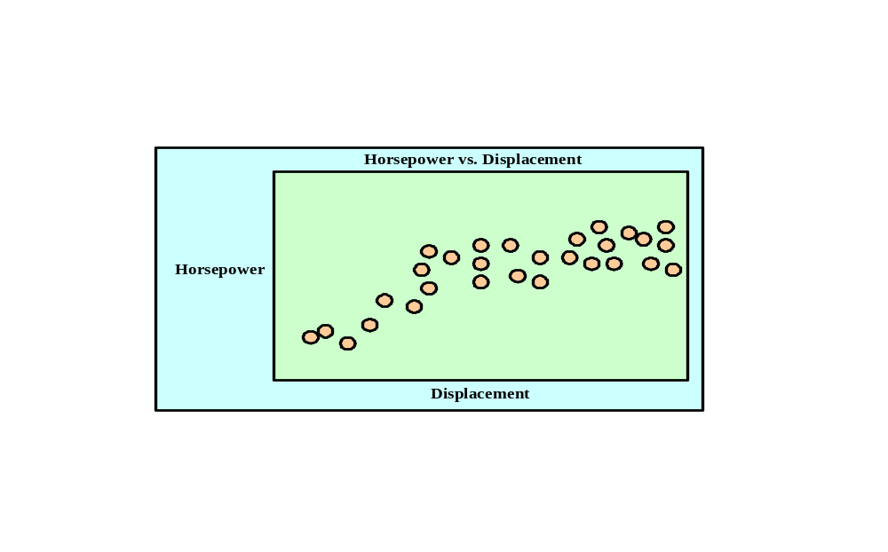

Data transformations into information can be accomplished in many ways, using simple tabulation, graphics, statistical modeling, etc.

- Define dirty data and identify some of its sources.
Dirty data is data that contains inaccuracies or inconsistencies (i.e. data that lacks integrity). Dirty data may result from a lack of enforcement of integrity constraints, typographical errors, the use of synonyms and homonyms across systems, the use of nonstandard abbreviations, or differences in the decomposition of composite attributes.

- What is data quality, and why is it important?
Data quality is a comprehensive approach to ensuring the accuracy, validity, and timeliness of the data. Data quality is important because without quality data, accurate and timely information cannot be produced. Without accurate and timely information, it is difficult (impossible?) to make good decisions; and without good decisions, organizations will fail in their competitive environments.

- Explain the interactions among end user, data, information, and decision-making. Draw a diagram and explain the interactions.

See Section 16-1. The interactions are illustrated in Figure 16.1.

Emphasize the end user's role throughout the process. It is the end user who must analyze data to produce the information that is later used in decision making. Most business decisions create additional data that will be used to monitor and evaluate the company situation. Thus data will be, or should be, recycled in order to produce feedback concerning an action's effectiveness and efficiency.

- Suppose that you are a DBA. What data dimensions would you describe to top-level managers to obtain their support for endorsing the data administration function?

The first step will be to emphasize the importance of data as a company asset, to be managed as any other asset. Top-level managers must understand this crucial notion and must be willing to commit company resources to manage data as an organizational asset.

The next step is to identify and define the need for and role of the DBMS in the organization. Refer the student to Section 16-2 and apply the concepts discussed in this section to a teacher-selected organization. Managers and end users must understand how the DBMS can enhance and support the work of the organization at all levels (top management, middle management, and operational.)

Finally, the impact of a DBMS introduction into an organization must be illustrated and explained. Refer to Section 16-3 to accomplish this task. Note particularly the technical, managerial, and cultural aspects of the process.

- How and why did database management systems become the organizational data management standard in organizations? Discuss some of the advantages of the database approach over the file-system approach.

Contrast the file system's "single-ownership" approach with the DBMS's "shared-ownership." Make sure that students are made aware of the change in focus or function when the shift from file system to the DBMS occurs. In other words, show what happens when the data processing (DP) department becomes a management information systems (MIS) department. Using Section 16-3, discuss how the change from DP to MIS shifts data management from an operational level to a tactical or strategic level.

- Using a single sentence, explain the role of databases in organizations. Then explain your answer.

The single sentence will be:

The database's predominant role is to support managerial decision making at all levels in the organization.

Refer to section 16-2 for a complete explanation of the role(s) played by an organization's DBMS.

- Define security and privacy. How are these two concepts related?

Security means protecting the data against accidental or intentional use by unauthorized users. Privacy deals with the rights of people and organizations to determine who accesses the data and when, where, and how the data are to be used.

The two concepts are closely related. In a shared system, individual users must ensure that the data are protected from unauthorized use by other individuals. Also, the individual user must have the right to determine who, when, where, and how other users use the data. The DBMS must provide the tools to allow such flexible management of the data security and access rights in a company database.

- Describe and contrast the information needs at the strategic, tactical, and operational levels in an organization. Use examples to explain your answer.

See Section 16-2 to contrast the different DBMS roles at each managerial level. Use Figures 16.3-16.5 as the basis for your discussions.

- What special considerations must you take into account when introducing a DBMS into an organization?

See Section 16-3. We suggest that you start a discussion about the special considerations (managerial, technical, and cultural) to be taken into account when a new DBMS is to be introduced in an organization. For example, focus the discussion on such questions as:
- What about retraining requirements for the new system?
- Who needs to be retrained?
- What must be the type and extent of the retraining?
- Is it reasonable to expect some resistance to change
- from the computer services department administrator(s)?
- from secretaries?
- from technical support personnel?
- from other departmental end users?
- How will the resistance in the preceding question be manifested?
- How will you deal with such resistance?

- Describe the DBA's responsibilities.

The database administrator (DBA) is the person responsible for the control and management of the shared database within an organization. The DBA controls the database administration function within the organization.

The DBA is responsible for managing the overall corporate data resource, both computerized and non-computerized. Therefore, the DA is given a higher degree of responsibility and authority than the DBA. Depending on organizational style, the DBA and DA roles may overlap and may even be combined in a single position or person.

The DBA position requires both managerial and technical skills. Refer to section 16-5 and Table 16.1 to explain and illustrate the general responsibilities of the DA and DBA functions.

- How can the DBA function be placed within the organization chart? What effect(s) will such placement have on the DBA function?

The DBA function placement varies from company to company and may be either a staff or line position. In a staff position, the DBA function creates a consulting environment in which the DBA is able to devise the overall data-administration strategy but does not have the authority to enforce it. In a line position, the DBA function has both the responsibility and the authority to plan, define, implement, and enforce the policies, standards and procedures.

- Why and how are new technological advances in computers and databases changing the DBA's role?

See Section 16-5, particularly Section 16-5b, "The DBA's Technical Role." Then tie this discussion to the increasing use of web applications.

The DBA function is probably one of the most dynamic functions of any organization. New technological developments constantly change the DBA function. For example, note how each of the following has an effect on the DBA function:
- the development of the DDBMS
- the development of the OODBMS
- the increasing use of LANs
- the rapid integration of Intranet and Extranet applications and their effects on the database design, implementation, and management. (Security issues become especially important!)

- Explain the DBA department's internal organization, based on the DBLC approach.

See Section 16-4, especially Figures 16.4 and 16.5.

- Explain and contrast the differences and similarities between the DBA and DA.

See Section 16-5, especially Table 16.1.

- Explain how the DBA plays an arbitration role for an organization's two main assets. Draw a diagram to facilitate your explanation.

See Section 16-5, especially Figure 16.6.

- Describe and characterize the skills desired for a DBA.

See Section 16-5, especially Table 16.2.

- What are the DBA's managerial roles? Describe the managerial activities and services provided by the DBA.

See Section 16-5a, especially Table 16.3.

- What DBA activities are used to support end users?

See Section 16-5a.

- Explain the DBA's managerial role in the definition and enforcement of policies, procedures, and standards.

See Section 16-5a.

- Protecting data security, privacy, and integrity are important database functions. What activities are required in the DBA's managerial role of enforcing these functions?

See Section 16-5a.

- Discuss the importance and characteristics of database data backup and recovery procedures. Then describe the actions that must be detailed in backup and recovery plans.

See Section 16-5a.

- Assume that your company assigned you the responsibility of selecting the corporate DBMS. Develop a checklist for the technical and other aspects involved in the selection process.

See Section 16-5b. The checklist is shown in the "DBMS and Utilities Evaluation, Selection, and Installation" segment.

- Describe the activities that are typically associated with the design and implementation services of the DBA technical function. What technical skills are desirable in the DBA's personnel?

See Section 16-5b.

- Why are testing and evaluation of the database and applications not done by the same people who are responsible for the design and implementation? What minimum standards must be met during the testing and evaluation process?

See Section 16-5b. Note particularly the material in the "Testing and Evaluation of databases and Applications" segment.

- Identify some bottlenecks in DBMS performance, and then propose some solutions used in DBMS performance tuning.

See Section 16-5b. Also see Chapter 11, “Database Performance Tuning and Query Optimization.”

- What are the typical activities involved in the maintenance of the DBMS and its utilities and applications? Would you consider application performance tuning to be part of the maintenance activities? Explain your answer.

See Section 16-5b. Database performance tuning is part of the maintenance activities. As the database system enters into operation, the database starts to grow. Resources initially assigned to the application are sufficient for the initial loading of the database. As the system grows, the database becomes bigger, and the DBMS requires additional resources to satisfy the demands on the larger database. Database performance will decrease as the database grows and more users access it.

- How do you normally define security? How is your definition of security similar to or different from the definition of database security in this chapter?

See Section 16-6. The levels are highly restricted, confidential, and unrestricted.

- What are the levels of data confidentiality?

See Section 16-6.

- What are security vulnerabilities? What is a security threat? Give some examples of security vulnerabilities that exist in different IS components.

See Section 16-6b.

- Define the concept of a data dictionary, and discuss the different types of data dictionaries. If you were to manage an organization's entire data set, what characteristics would you look for in the data dictionary?

See Section 16-7a.

- Using SQL statements, give some examples of how you would use the data dictionary to monitor the security of the database.

NOTE
If you use IBM's DB2, the names of the main tables are SYSTABLES, SYSCOLUMNS, and SYSTABAUTH.

See Section 16-7a.

- What characteristics do a CASE tool and a DBMS have in common? How can these characteristics be used to enhance the data administration?

See Section 16-7b.

- Briefly explain the concepts of information engineering (IE) and information systems architecture (ISA). How do these concepts affect the data administration strategy?

See Section 16-8.

- Identify and explain some of the critical success factors in the development and implementation of a good data administration strategy.

See Section 16-8.

- How have cloud-based data services affected the DBA’s role.?

The answer to this question is explained in detail in section 16-9.

- What is the tool used by Oracle to create users?

See Section 16-10d. Note the Oracle Security Manager screen in Figure 16.13 and the Create user Dialog Box in Figure 16.14.

- In Oracle, what is a tablespace?

See Section 16-10c. The following summary is useful:
- A tablespace is a logical storage space.
- Tablespaces are primarily used to logically group related data.
- Tablespace data are physically stored in one or more datafiles.

- In Oracle, what is a database role?

See Section 16-10d. A database role is a named collection of database access privileges that authorize a user to perform specified actions on the database. Examples of roles are CONNECT, RESOURCE, and DBA.

- In Oracle, what is a datafile? How does it differ from a file systems file?

See Section 16-10c. The following summary will be useful:
- A database is composed of one or more tablespaces. Therefore, there is a 1:M relationship between the database and its tablespaces.
- Tablespace data are physically stored in one or more datafiles. Therefore, there is a 1:M relationship between tablespaces and datafiles.
- A datafile physically stores the database data.
- Each datafile is associated with one and only one tablespace. (But each datafile can reside in a different directory on the same hard disk -- or even on different disks.)

In contrast to the datafile, a file system's file is created to store data about a single entity, and the programmer can directly access the file. But file access requires the end user to know the structure of the data that are stored in the file.

While a database is stored as a file, this file is created by the DBMS, rather than by the end user. Because the DBMS handles all file operations, the end user does not know -- nor does that end user need to know -- the database's file structure. When the DBA creates a database -- or, more accurately, uses the Oracle Storage Manager to let Oracle create a database -- Oracle automatically creates the necessary tablespaces and datafiles.

We have summarized the basic database components logically in Figure Q16.39.

Figure Q16.39 The Logical Tablespace and Datafile Components
of an Oracle Database
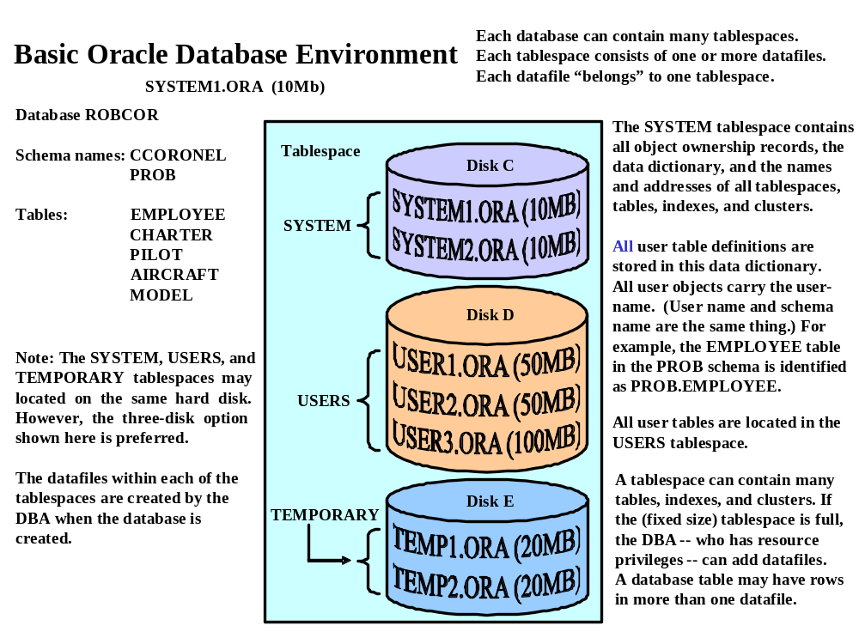

- In Oracle, what is a database profile?

See Section 16-10d. A profile is a named collection of database settings that control how much of the database resource can be used by a given user.

